|  |  |  |  |  |  |
| --- | --- | --- | --- | --- | --- |
| Date | 28-Nov-22 | | | Tester Name | Mayuri Patel |
| Environment | Penfax - Test | | | Login used |  |
| Operating System | Windows | Version: | Update: | | |
| Software Used | Edge | Version: | Update: | | |
| Not Applicable | Version: | Update: | | |
| Release version | 22.4.1 | | | | |
| Title | Death | | | | |
| Test Type | Regression | | | | |
| Test Scenario | Process a death payout to the Estate | | | | |
|  |  | | | | |
| Expected Results | Deceased member’s investment account should show $0 once death payout is processed.  Benefit Receipt and T4A slip should be generated under deceased member’s account.  Verify that the Relationship is Estate under DC Benefit Calculation. | | | | |
| Pass/Fail | Pass | | | JIRA# | N/A |

Describe your steps with screenshots:

1. In PENFAX5 do a search for deferred survivor member. Click on the stakeholder ID.

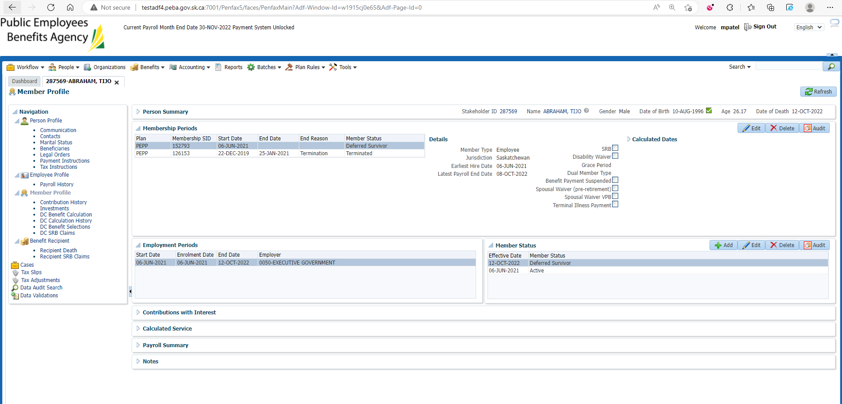

1. Process DC Benefit Selection. Make sure Date of Death is populated.

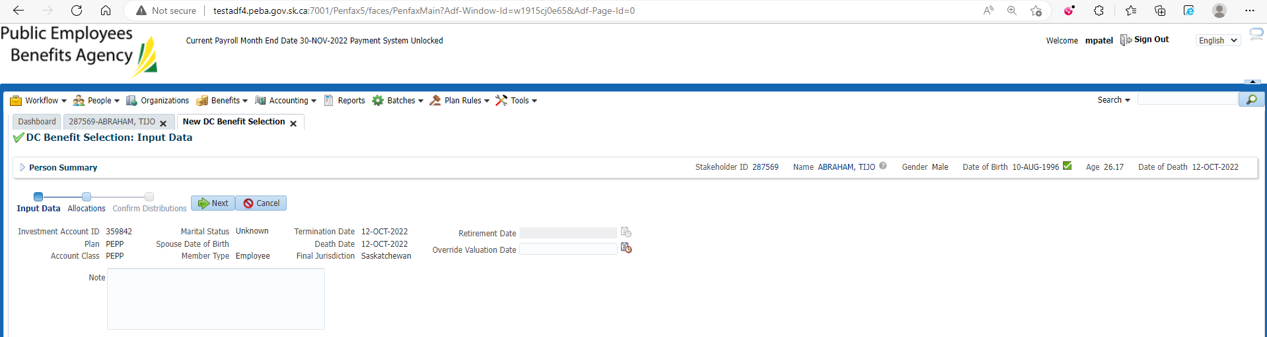

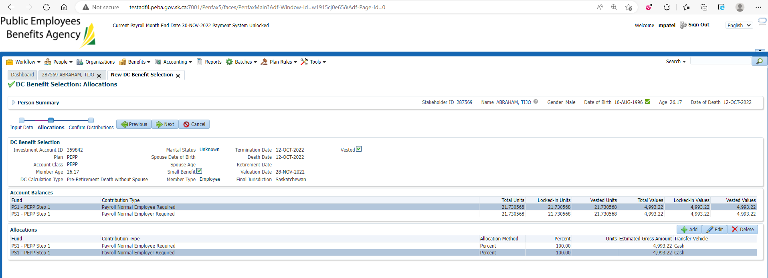

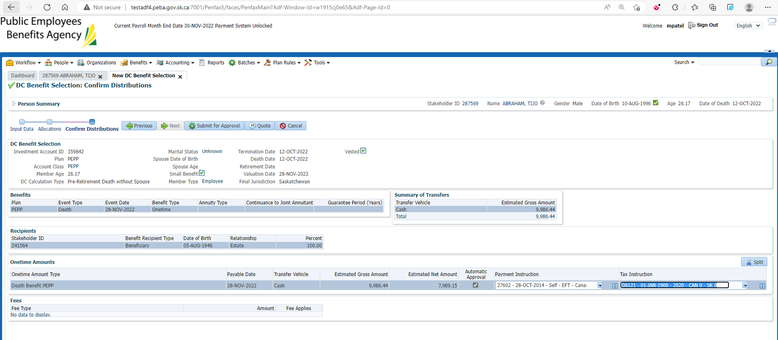

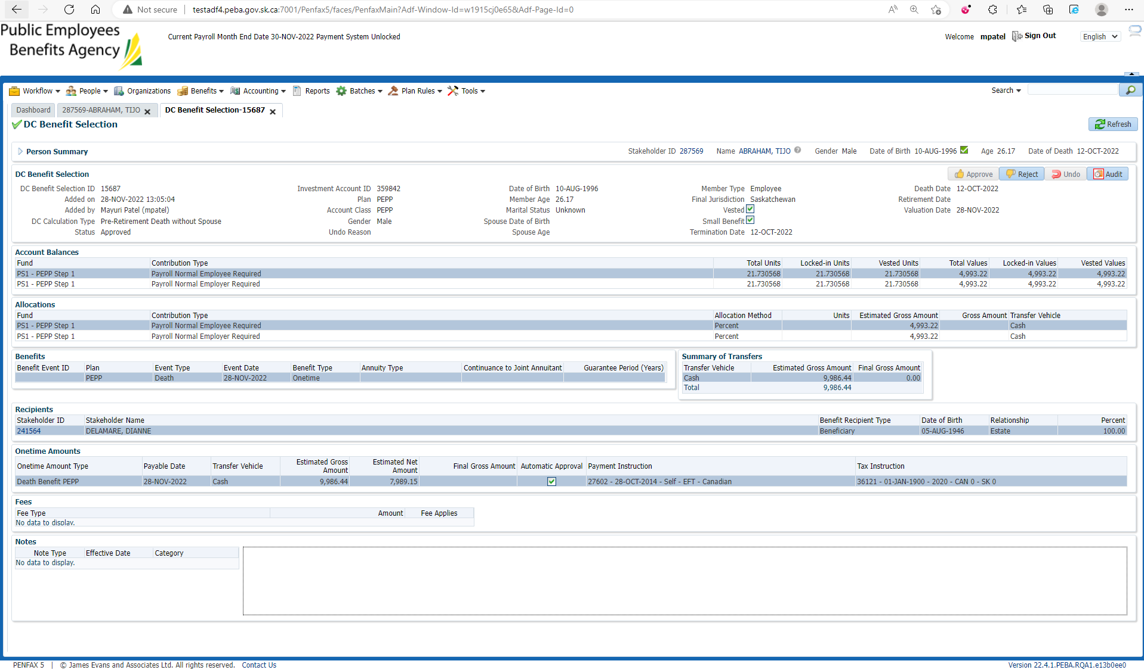

1. Approved Benefit Selection can be seen under Member Profile -> DC Benefit Selection

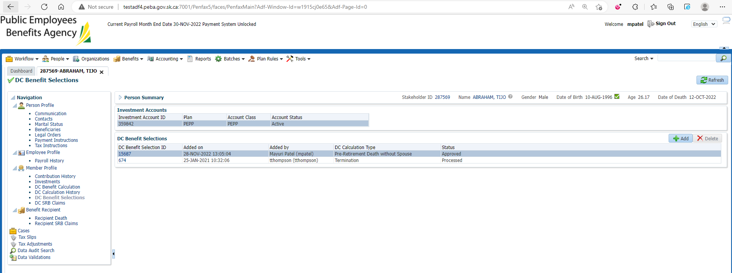

1. Wait for overnight batches to run.

Bring up the deceased member.

Click on Investments.

Make sure the account balance is now 0.

Make sure the account status is now inactive.

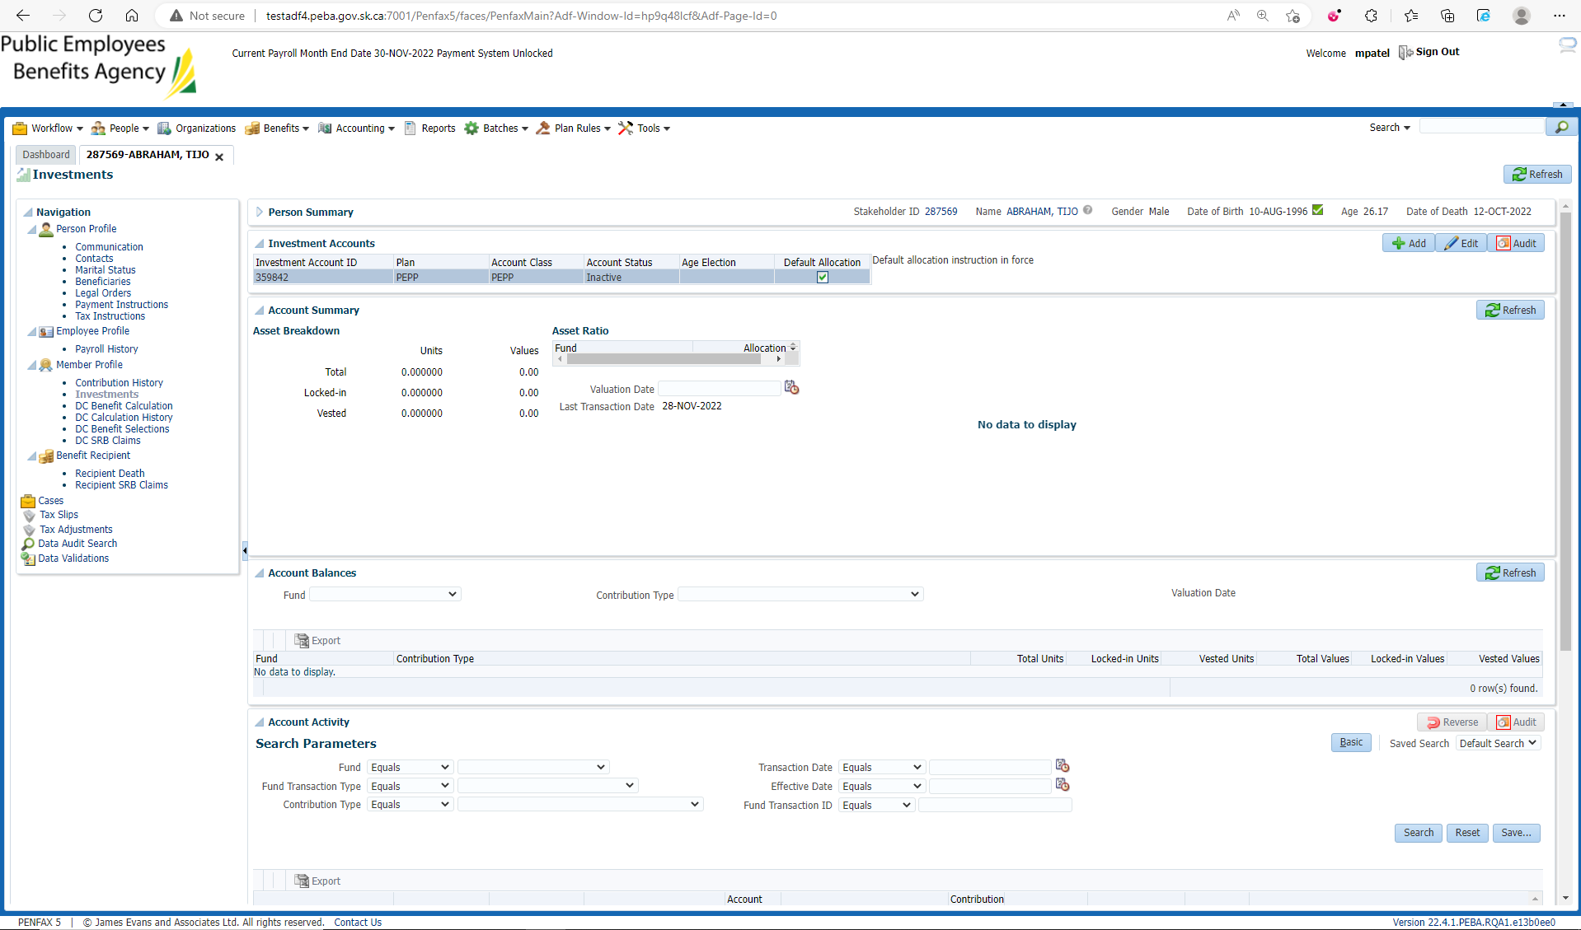

1. Go to the member profile. Make sure the member status is death.

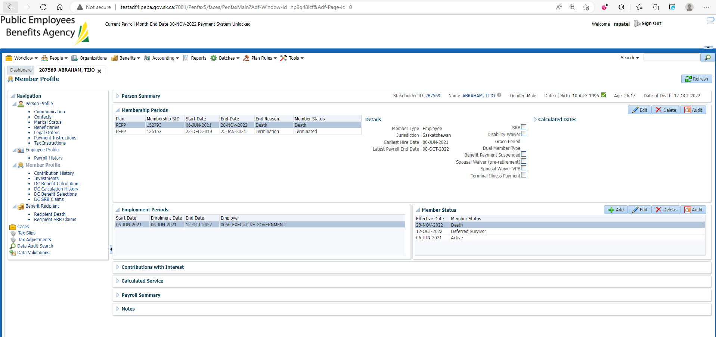

1. They should have a Benefit Recipient Tab available. Open the benefit recipient tab.

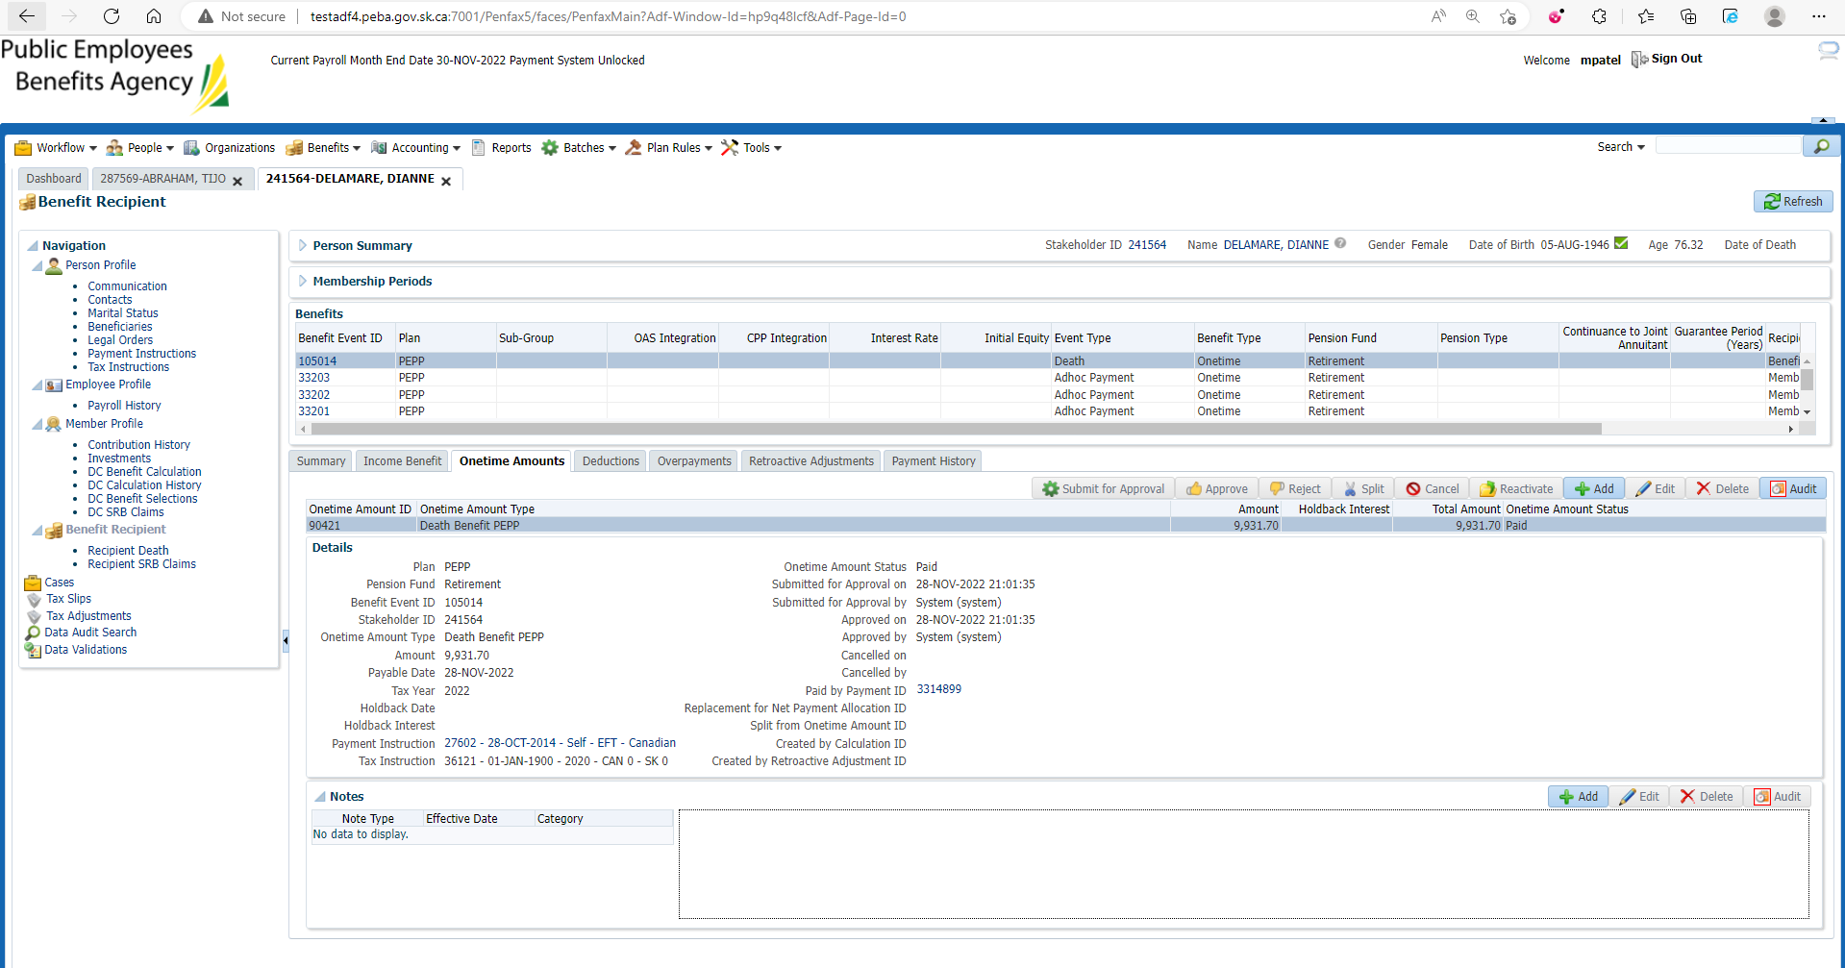

1. Click on Tax slips.

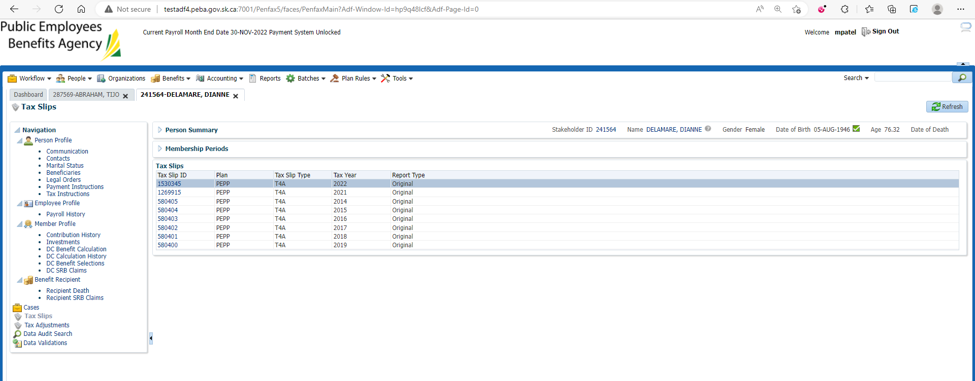

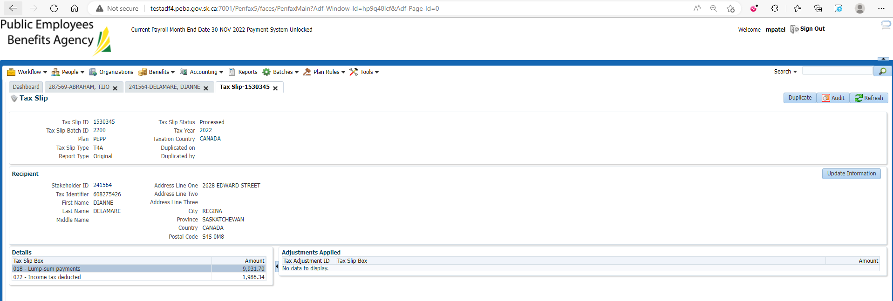

1. Go to Communication -> Outbound Documents. You can find the T4A slip there.

